(About 342 words)

Organizing the Favorites Menu
by Glenn Richards, Emeritus Member of the Lake-Sumter Computer Society, Leesburg, FL
grich32(at)yahoo.com
www.lscs.us
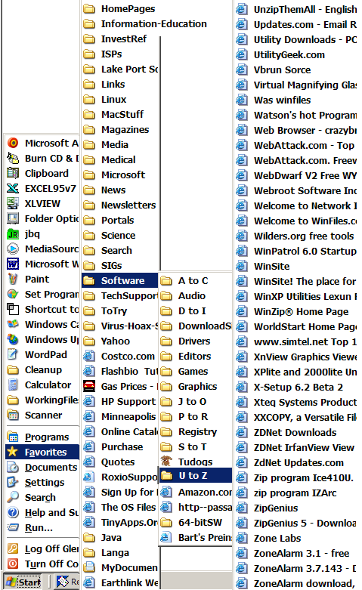
This is a follow-up on a tip from Worldstart. I have been using the method for years. When you collect shortcuts to web sites like I do the Favorites menu gets difficult to manage without some organizing.

It is easy to add sub-folders to the Favorites main folder, either via the Internet Explorer menu item Favorites, or using Windows Explorer.

The figure shows a main Favorites subfolder I named “Software.” Under that folder I have a subfolder named “A to C,” etc. down to “U to Z.” The right-most column shows some of the contents of the UtoZ subfolder.

I split the alphabetic range of the subfolders so that the height of the contents of any folder does not exceed the vertical space on the Desktop. The figure has squeezed the display horizontally to make more room for these words.

My Software folder is for web sites where I have found worthwhile programs for download. One of its subfolders is “Tudogs,” a web site that has shortcuts to hundreds of free programs. I have acquired many of them for the group’s CDs.

The method of creating the subfolders using Windows Explorer that I use is to have WE in a two-pane mode with the Favorites folder highlighted in the left pane. Right-click in the right pane, New, Folder, and give the folder a name of you’re choosing. This method can be cascaded as far as you want to go.

The above method of organization can also be used to consolidate items in your Start, Programs menu. Use WE to open your Programs folder at C:\Documents and Settings\<your own menu>\Start Menu\Programs, create subfolders for categories of menu items, and move appropriate shortcuts to this new subfolder. This can reduce the height of the Programs menu so it will fit on the screen.

My Favorites folder has 1968 files (web addresses) in 136 subfolders occupying 403KB, with no web address more than two clicks away.

There is no restriction against any non-profit group using this article as long as it is kept in context with proper credit given the author. The Editorial Committee of the Association of Personal Computer User Groups (APCUG), an international organization of which this group is a member, brings this article to you.

